Ideation Phase
Define the Problem Statements

Date | 02/10/2026
Team ID | SWTID-2026-3118
Project Name | IMPORT DATA USING TRANSFORM MAPS (SPREADSHEET)
Maximum Marks | 2 Marks

Customer Problem Statement Template:
Create a problem statement to understand your customer's point of view. The Customer Problem Statement template helps you focus on what matters to create experiences people will love.
A well-articulated customer problem statement allows you and your team to find the ideal solution for the challenges your customers face. Throughout the process, you’ll also be able to empathize with your customers, which helps you better understand how they perceive your product or service.
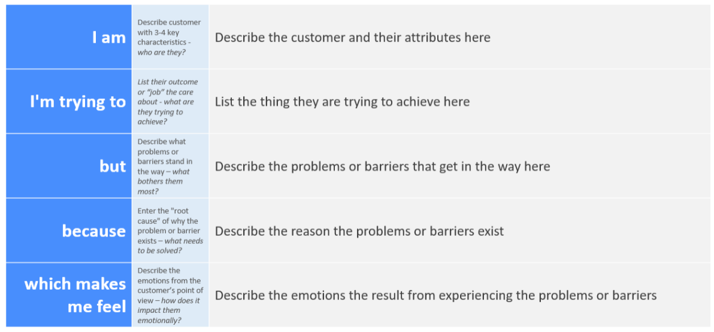
Reference: https://miro.com/templates/customer-problem-statement/
Example:

Problem Statement (PS) | I am (Customer) | I’m trying to | But | Because | Which makes me feel
PS-1 | HR data coordinator | Load employee spreadsheets into ServiceNow accurately | Mapping and checking each row takes time and can introduce errors | Employee data must reach the correct target fields consistently | Concerned about delays and incorrect employee records
PS-2 | ServiceNow administrator | Process repeat imports so new staff are added and existing staff are updated | Repeated uploads can create duplicates or miss changed details | Each employee needs a reliable matching key across import runs | Unsure whether the employee table stays accurate

